**Characterizing the current state of a propulsion engine: A comparison of machine learning frameworks**

*CASI AERO 2019 – 26th CASI Aerospace Propulsion Symposium*

|  |  |  |
| --- | --- | --- |
| **Srishti Sehgal** 1,3 | **Catherine Cheung 2** | **Julio J Valdes 2** |
| [*srishti.sehgal@nrc-cnrc.gc.ca*](mailto:srishti.sehgal@nrc-cnrc.gc.ca)  *OR* [*srishti.sehgal@mail.utoronto.ca*](mailto:srishti.sehgal@mail.utoronto.ca) *(613) 991 9646* | [catherine.cheung@nrc-cnrc.gc.ca](mailto:catherine.cheung@nrc-cnrc.gc.ca) | [julio.valdes@nrc-cnrc.gc.ca](mailto:julio.valdes@nrc-cnrc.gc.ca) |

*1 University of Toronto – National Research Council Canada Co-op Student*

*2 National Research Council Canada*

*3 Corresponding author*

**Extended Abstract**

Introduction

The operation of a complex system, like a propulsion diesel engine (PDE), instantiates the need for equipment health monitoring and fault diagnosis to improve its safety, economy and dependability. Typically, a machine learning model can examine relationships between equipment steady state physical characteristics and other indicators of equipment health to systematically generate failure predictions when these parameters deviate from pre-defined settings. The challenge is that many canonical models assume an equal proportion of objects in each considered class. However, for many complex systems, the distribution of failed to healthy steady state examples is skewed. This poses a difficulty for these algorithms, as they will be biased towards the majority healthy class.

To combat the imbalanced dataset, NRC Aerospace studied the impact of *data reduction* on a classification task for sample PDE data [1]. Although some classification and anomaly detection methods proved fruitful, there is interest to extend the study into the effects of *dimension reduction* on classification performance. In this process, a dataset with a large feature set is transformed into a dataset with a smaller feature set while ensuring to convey the same information concisely.

NRC Aerospace is investigating the use of a multi-task framework (MTF) to extract features that may share a complex non-linear relationship. Inspiration for multi-task learning can be seen from human learning activities. For instance, a native French speaker learning Italian will be able to use shortcuts to speed up the learning process and learn to speak their own language better. If learning tasks are related, training them jointly can lead to a performance improvement than if they were trained separately. Multi-task learning aims to improve the generalization performance of several related tasks. Similar to human learning, the knowledge contained in one task can be leveraged by other tasks [2, 3].

This paper describes the structure of the MTF to share knowledge and develop a common feature set among tasks. Such an effort is prudent in order to improve training time, improve classification accuracy and set a direction towards the future development of efficient frameworks. To quantify the success of the MTF, classification results are evaluated with binary classification performance metrics such as sensitivity and precision. These results are then compared with outputs from methods that do not use dimension reduction prior to classification.

Preliminary Results

In the first framework, various methods including supervised and semi-supervised methods are used to classify each sample in the dataset as a healthy operating condition or as a deteriorated one. Only 7% of training (171836 points) and 7% of testing (58323 points) are failed states.

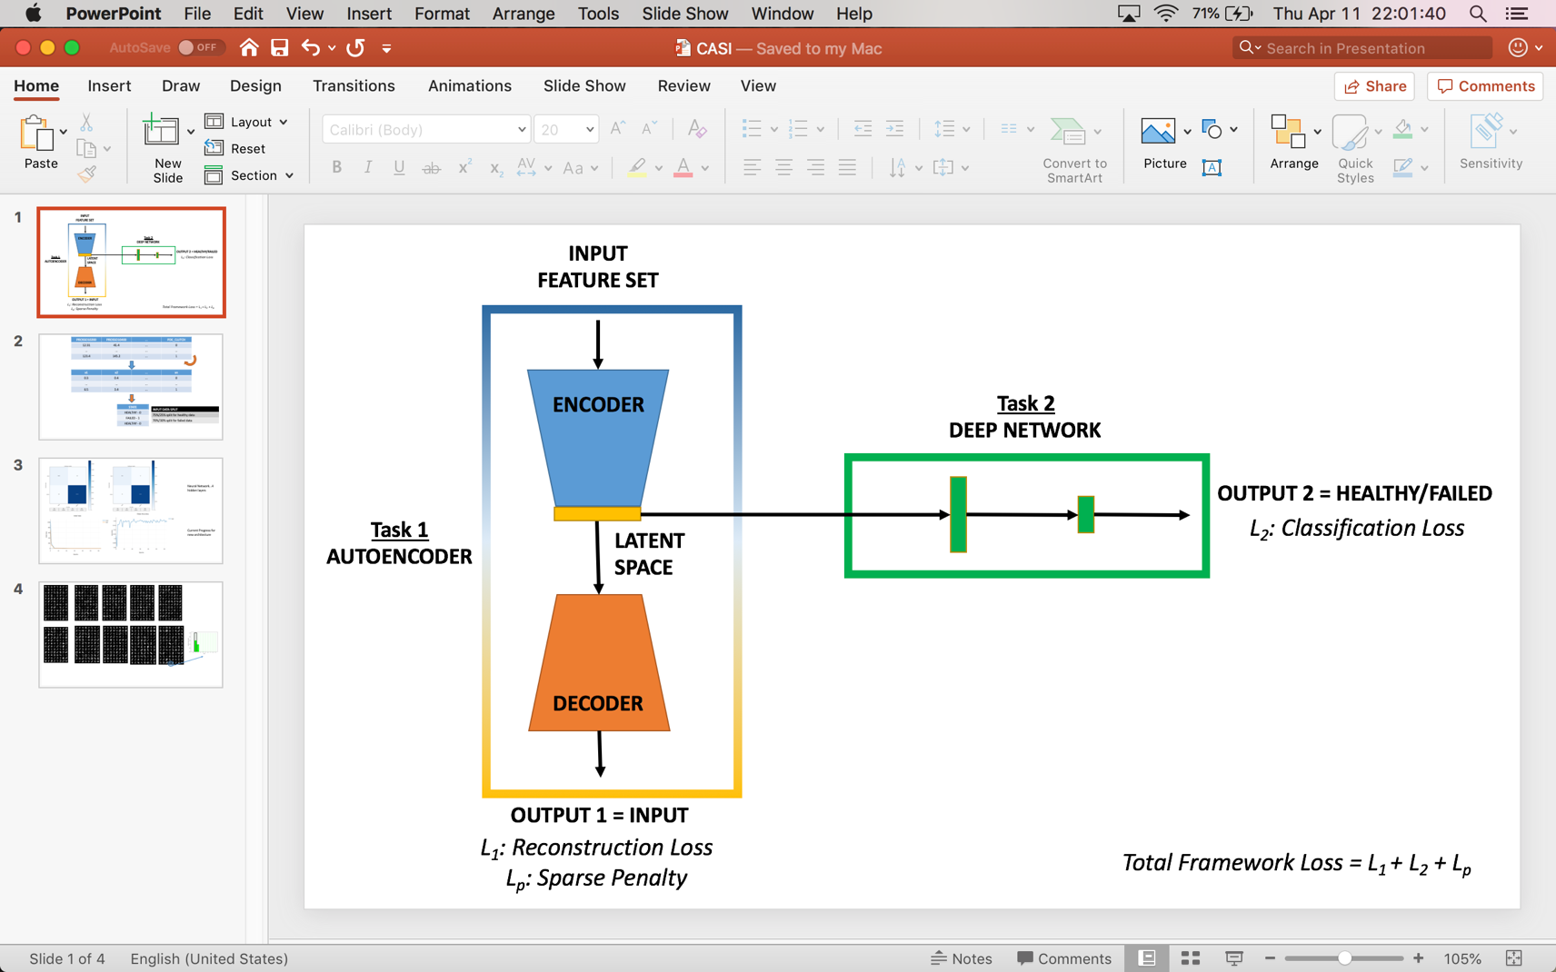

**Figure 1 MTF Structure showing two learning tasks and total framework optimization function**

As shown in Figure 1, there are two tasks in this MTF. The first task is to develop a sparse model that can reconstruct the dataset. By training the autoencoder to reconstruct the input while forcing the encoding through a smaller layer, the network is forced to learn a compressed representation. If the input were completely random, then this latent representation will not take on useful properties. If some of the input features are correlated, then this algorithm will be able to discover some of those correlations. This model also introduces a penalty term to the optimization function, adding constraints to feature learning for an even more concise expression of the input data and avoid overfitting [4]. At the same time, another learning task is to attempt classification of the samples as either healthy or failed states. The primary difference between this MTF and the previous framework is that the second learning task will attempt classification on the latent space produced by the first task.

Listed in Equations 1-4 and in Table 1, receiver operating characteristic metrics are employed to evaluate the performance of this classification methodology. A perfect classifier will only have elements along its main diagonal. In this study, a true positive refers to a failed steady state predicted as a failed state, while a true negative refers to a healthy steady state correctly predicted as a healthy state. False positives, or false alarms, should be minimized to reduce complacency in operator response. False negatives also should be minimized, if not avoided, to ensure that a system failure is not overlooked. Since the data is imbalanced, metrics such as PPV and FNR should be considered. An ideal classifier is one that has a PPV equal to 1 and the FNR equal to 0.

**Table 1 Confusion matrix as a basis for Receiver Operating Characteristic Metrics**

|  |  |  |  |
| --- | --- | --- | --- |
|  |  | Ground Truth/Observed | |
|  |  | Failed | Healthy |
| Model Prediction | Failed | True Positive (TP) | False Positive (FP) |
| Healthy | False Negative (FN) | True Negative (TN) |

|  |  |  |  |
| --- | --- | --- | --- |
| **Equation 1 True Positive Rate (TPR)** | $$FPR= \frac{FP}{\left(TN+FP\right)}$$**Equation 2 False Positive Rate (FPR)** | $$FNR= \frac{FN}{(TP+FN)}$$**Equation 3 False Negative Rate (FNR)** | $$PPV= \frac{TP}{\left(TP+FP\right)}$$**Equation 4 Positive Predictive Value (PPV)** |

Framework 1

As seen in Figures 2 and 3, the Neural Network classifier can differentiate failed steady states from healthy steady states very well in both training and testing sets. PPV is also very close to 1 and FNR is very close to 0. This suggests that the model is not being biased towards the high number of healthy steady state samples.

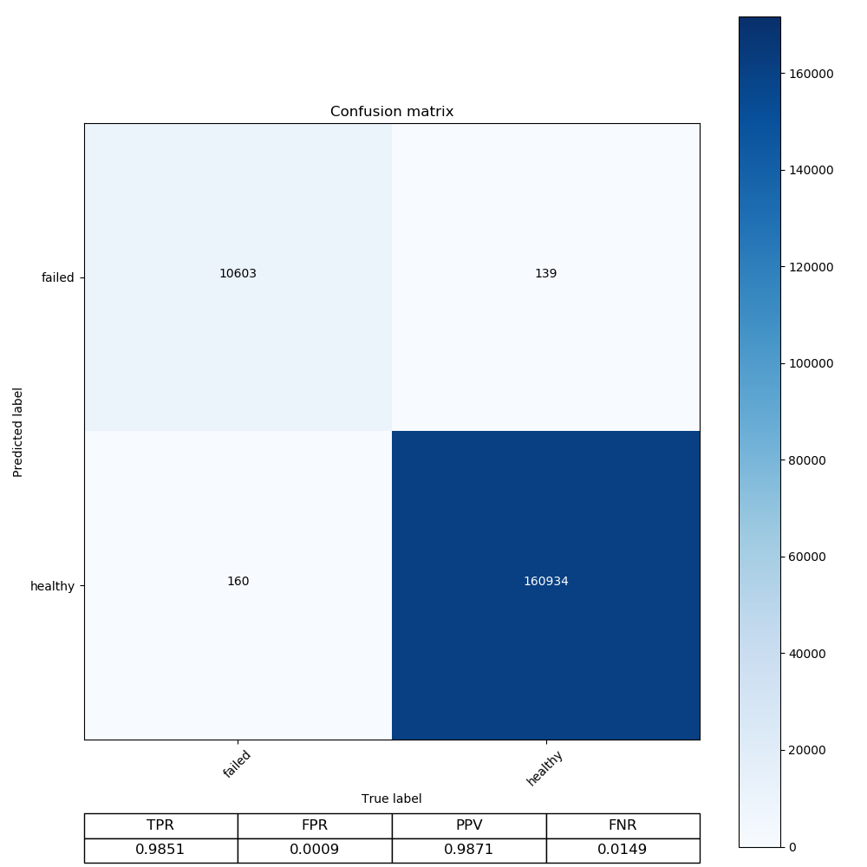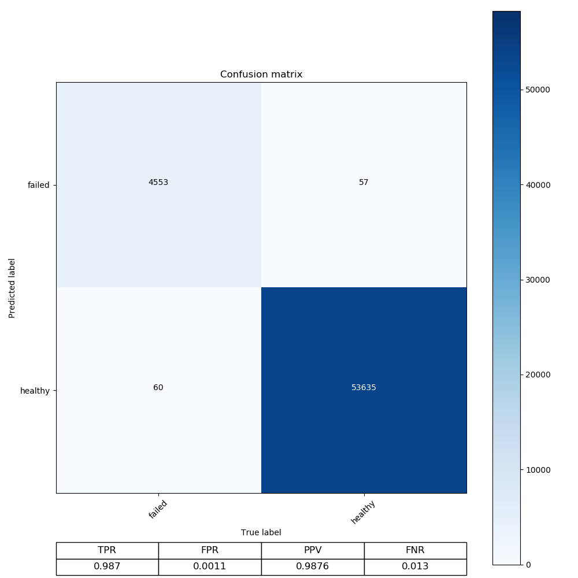

**Figure 3 Confusion matrix for testing set using Neural Network**

**Figure 2 Confusion matrix for training set using Neural Network**

*Framework 2*

As shown in Figure 4 and 5, the model was able to recreate the dataset very well in the first task. The final reconstruction loss was only 0.87% of the initial loss. Since the model did not learn the trivial identity function to reconstruct the input dataset, the latent representation retained information from the original input dataset with only 30 features instead of the original 51 features.

The second learning task used this latent space to train a Neural Network architecture similar to Framework 1. Its classification results are shown in Figures 6 and 7. Other hyperparameters such as choice of optimizer or choice of learning rate were kept constant to ensure that the only difference between the two frameworks would be architecture and the use of a latent dataspace. Although the TPR is slightly less than that of the Neural Network classifier from the first framework, PPV is slightly higher and the FPR is slightly lower in the testing set. The classification results of the MTF are similar to the results of Neural Network in Framework 1. A remarkable observation, however, is that the efficiency of the MTF was significantly better. For the same datasets, the MTF only required 25 epochs to converge whereas the latter required 200 epochs.

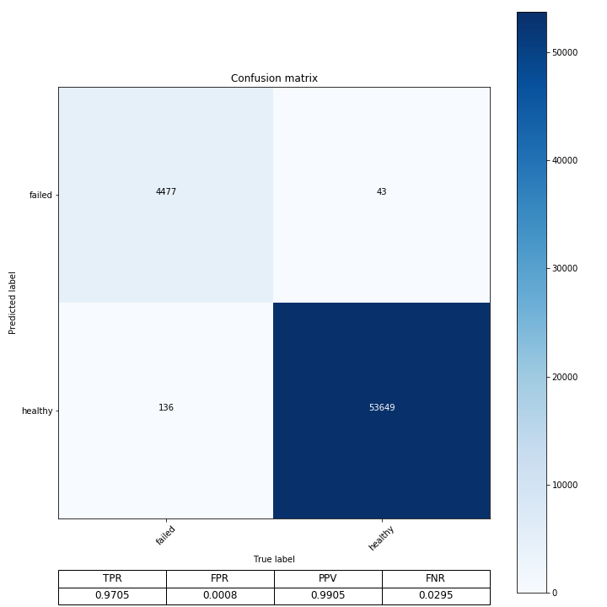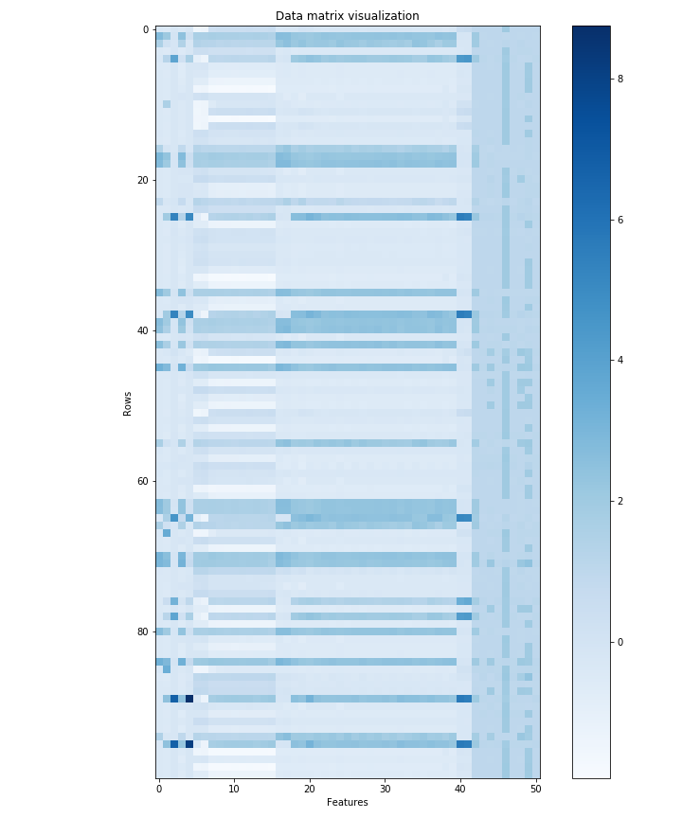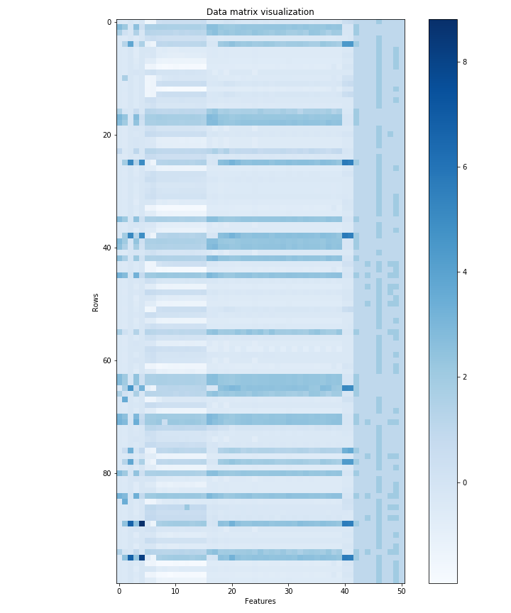

**Figure 5 Visualization of last 100 rows of original data matrix**

**Figure 4 Visualization of last 100 rows of model generated data matrix**

**Figure 7 Confusion matrix for testing set using MTF**

**Figure 6 Confusion matrix for training set using MTF**

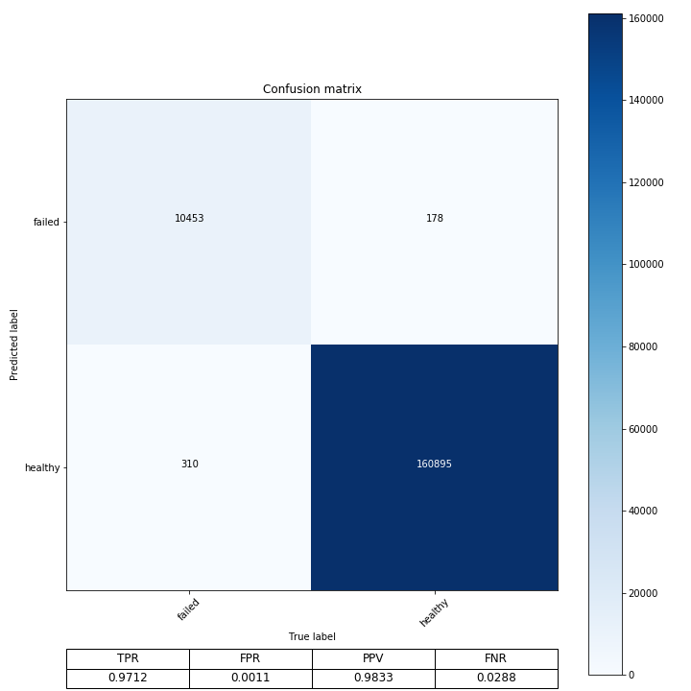

Conclusion

The main objective is to correctly identify healthy and failed states of a propulsion diesel engine. Results of an MTF that generated a lower-dimensional latent data space for classification were compared against a framework that did not use dimension reduction for classification. The study shows considerable promise for using an MTF to generate a latent data space for a classification problem with an imbalanced dataset. Though the prediction rates are similar to the previous framework, the time elapsed decreased by eightfold. This is a very significant outcome of the study because as datasets get larger, the time required to train a model will increase too. Furthermore, future real-time tools that use faster-to-train frameworks, like the MTF, can be developed to analyze sensor information and to provide more up-to-date and adaptive predictions. Thus, choosing a framework that will potentially decrease the amount of training time is important. Ultimately, being able to detect failures near-real-time during critical operation is significantly useful to: operators who will plan their next set of actions to avoid failure, maintainers who will understand where their efforts should be concentrated and engineers who can initiate improvements in new engine designs based on areas of recurring anomalies in historical data.

References

[1] Cheung, C., Valdes, J., Chavez, R., and Sehgal, S. (2019). Failure modelling of a propulsion subsystem: unsupervised and semi-supervised approaches to anomaly detection. *International Journal of Pattern Recognition and Artificial Intelligence.*

[2] Zhang, Y., Wei, Y., and Yang, Q. (2018). Learning to multitask. *Conference on Neural Information Processing Systems.* <https://papers.nips.cc/paper/7819-learning-to-multitask.pdf>

[3] Zhang, Y., and Yang, Q. (2018). A survey on multi-task learning. <https://arxiv.org/pdf/1707.08114.pdf>

[4] D. Yang, D., Lai, J., and Mei, L. (2016) Deep representations based on sparse auto-encoder networks for face spoofing detection. *Springer International Publishing*.